[TAB] Table of Contents

Overview of Program [OS]
Program Structure [STRUCT]
Functions [FUNC]
Description of Data Structures [DATA]
Global Variables [GLOB]
Cross References [X-Ref]
Index [IND]

[OS] Overview of Program

Chopsticks is an interactive console based operating system
that allows users to input commands to manipulate data and
to control the operating system.

[STRUCT] Program Structure

UML Diagrams

a. UML class diagrams
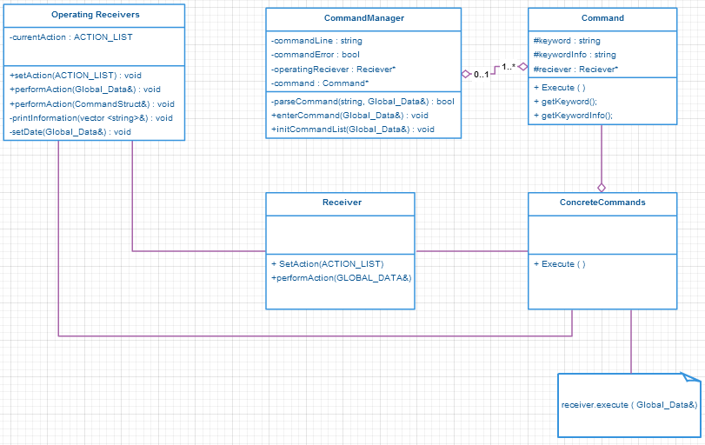

UML Diagram (Cont.)

b. List of the contents in each file
- List the functions/data structures and a brief description of each

[FUNC] Functions
a. Prototype
b. Parameters – data type, description
c. Return value, including returns when an error is encountered
- Description of what the function does

[DATA] Description of Data Structures
a. Use
b. Attributes – list including data types and brief description

[GLOB] Global Variables
a. List including data types and description

[X-Ref] Cross References
a. For each function, which functions does it call, and which functions call it?

[IND] Index

